For our upcoming season, we are planning on incorporating a new chairlift which will add a total new operating cost of $1.5mm. In order to account for this, we have investigated options to both increase profits and to decrease our other operating costs.

In order to best understand our place in the market, we utilized data on 283 other resorts nationwide, taking into account where we stand both in relation to ticket price as well as how we compare with respect to features which appear to have the largest impact on market price. We discarded any resorts which did not have pricing information, and used the rest in our analysis. As we began the analysis we conducted a state-by-state comparison, which revealed that Montana’s prices generally lie lower than several other states, and that even within that sphere Big Mountain’s prices are not the highest (Figure 1).

In the early stages of the analysis we investigated 25 features to establish which seemed to have the greatest correlation to ticket prices. Among those 25, we found that snow coverage (both snowfall and snow making), vertical drop and the longest run of a given resort tended to be the metrics that best predicted price, and those became the focus of our analysis.

In order to best model our data and make predictions, we then evaluated several models. Prior to this, we made our single change to the data in order to begin modeling: we assumed the values for any missing features of a resort to be 0. This was done because none of our models can work with datasets with missing values.

In establishing our models, we decided the best metric for an accurate model is the Mean of Absolute Errors, simply meaning a measure of how far a given value could be expected to be from the average. While training our model, we were able to establish a predictive ability of within $9 of an expected ticket price, which gave us the confidence to proceed.

Running our models, we identified that while Big Mountain is indeed priced toward the top end of our analysis, the features support this pricing. Big Mountain ranks very highly in vertical drop (figure 2), snow coverage (figure 3), total runs (figure 4) and skiable terrain (figure 5). Though these are all indications that Big Mountain has all the features required for a premium price point in the market, the model also identified that it is already at the optimal price point in the market, and that it will be best for our revenue and profit margins not to raise prices. The model did, however, provide a critical insight for operations: there is no notable dropoff in ticket prices or revenue with selective run closures. Therefore we can accomplish significant decreases in operation costs by closing several of our least-skied runs without any repercussions in ticket sales.

Therefore it is our recommendation that ticket prices remain at $81/day, but that we close up to 6 runs strategically to reduce the costs of operation on those runs. It would provide no benefit to extend runs or the skiable area beyond what they already are.

The analysis we have conducted however is exclusively on the features of the mountain itself, and not on further monetization of guests that are on-site. I would recommend further analysis on other revenue generating activities, including rentals, concessions and other ski supplies, as each of those areas may also lead to significant growth in revenue without great increases in operational costs.

**Figure 1 (State by state price comparison)**

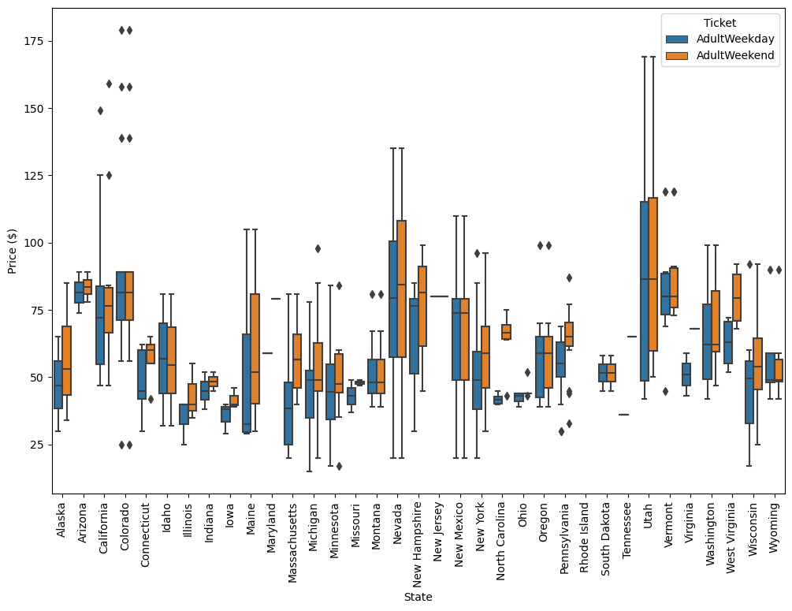

**Figure 2 (Vertical Drop)**

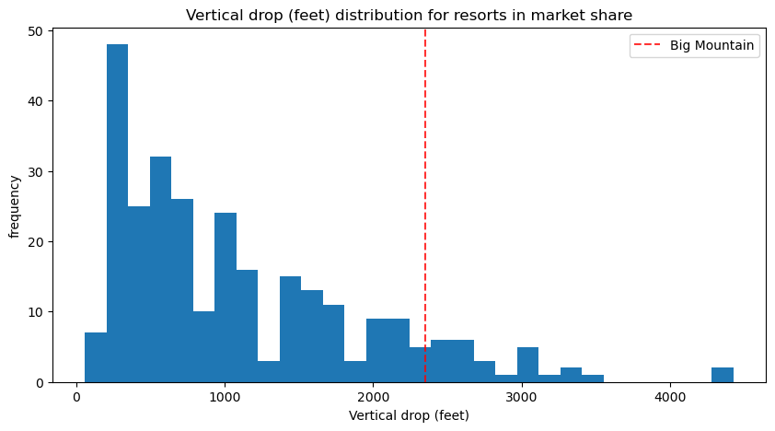

**Figure 3 (Snow coverage)**

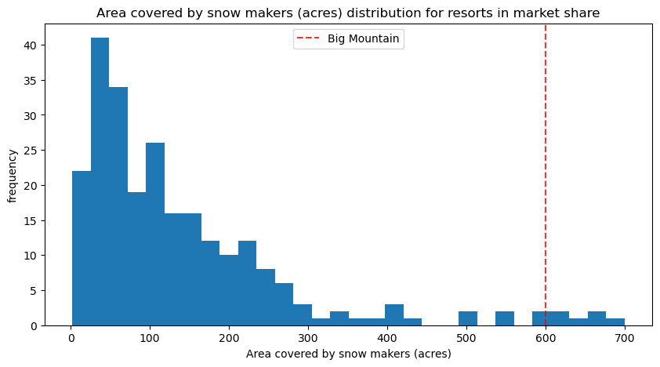

**Figure 4 (Total number of runs)**

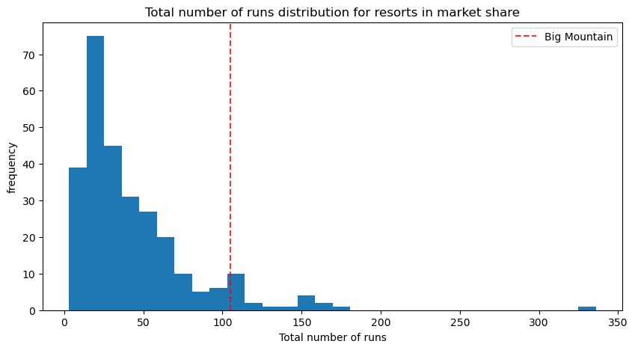

**Figure 5 (Skiable Terrain)**

